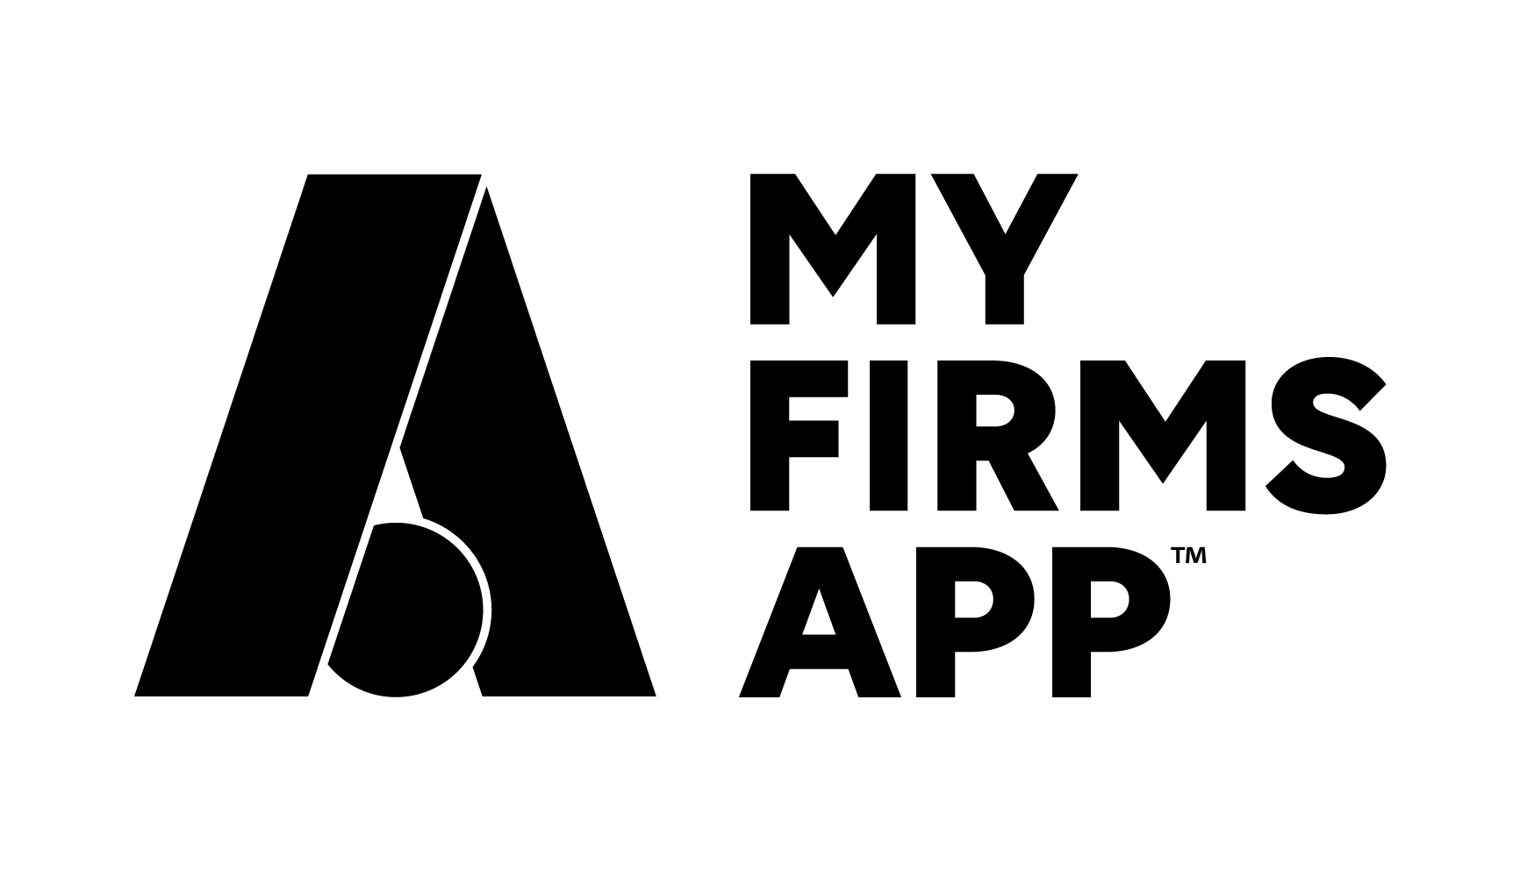
‘OneApp Plus’
VIP Download & Engagement service

As part of our commitment to you to ensure that your move to our ‘OneApp Plus’ platform is a smooth as possible, we have developed this VIP Download & Engagement service.

This is a complete hand-holding service over a 3-month period at zero cost. You get support and practical assistance in helping re-fresh your App users and downloads

What does the service include?

  - Your existing App remains live for 3 months to ensure migration of your users to your new App
  - Our team are available at any time with support or guidance
  - Access to your existing App data and user data (if you have segmentation currently)
  - Automated push message and on screen messages helping your existing users download your new, upgraded App
  - Pre-written email content (and optional letters) to send to your clients promoting your new App
  - Smartphone detection code for your website – driving downloads and engagement
  - Smart QR code

This is where you will find the specific resources we have written for you to use, information about what will happen automatically for you and links to your smart code detection and QR code.

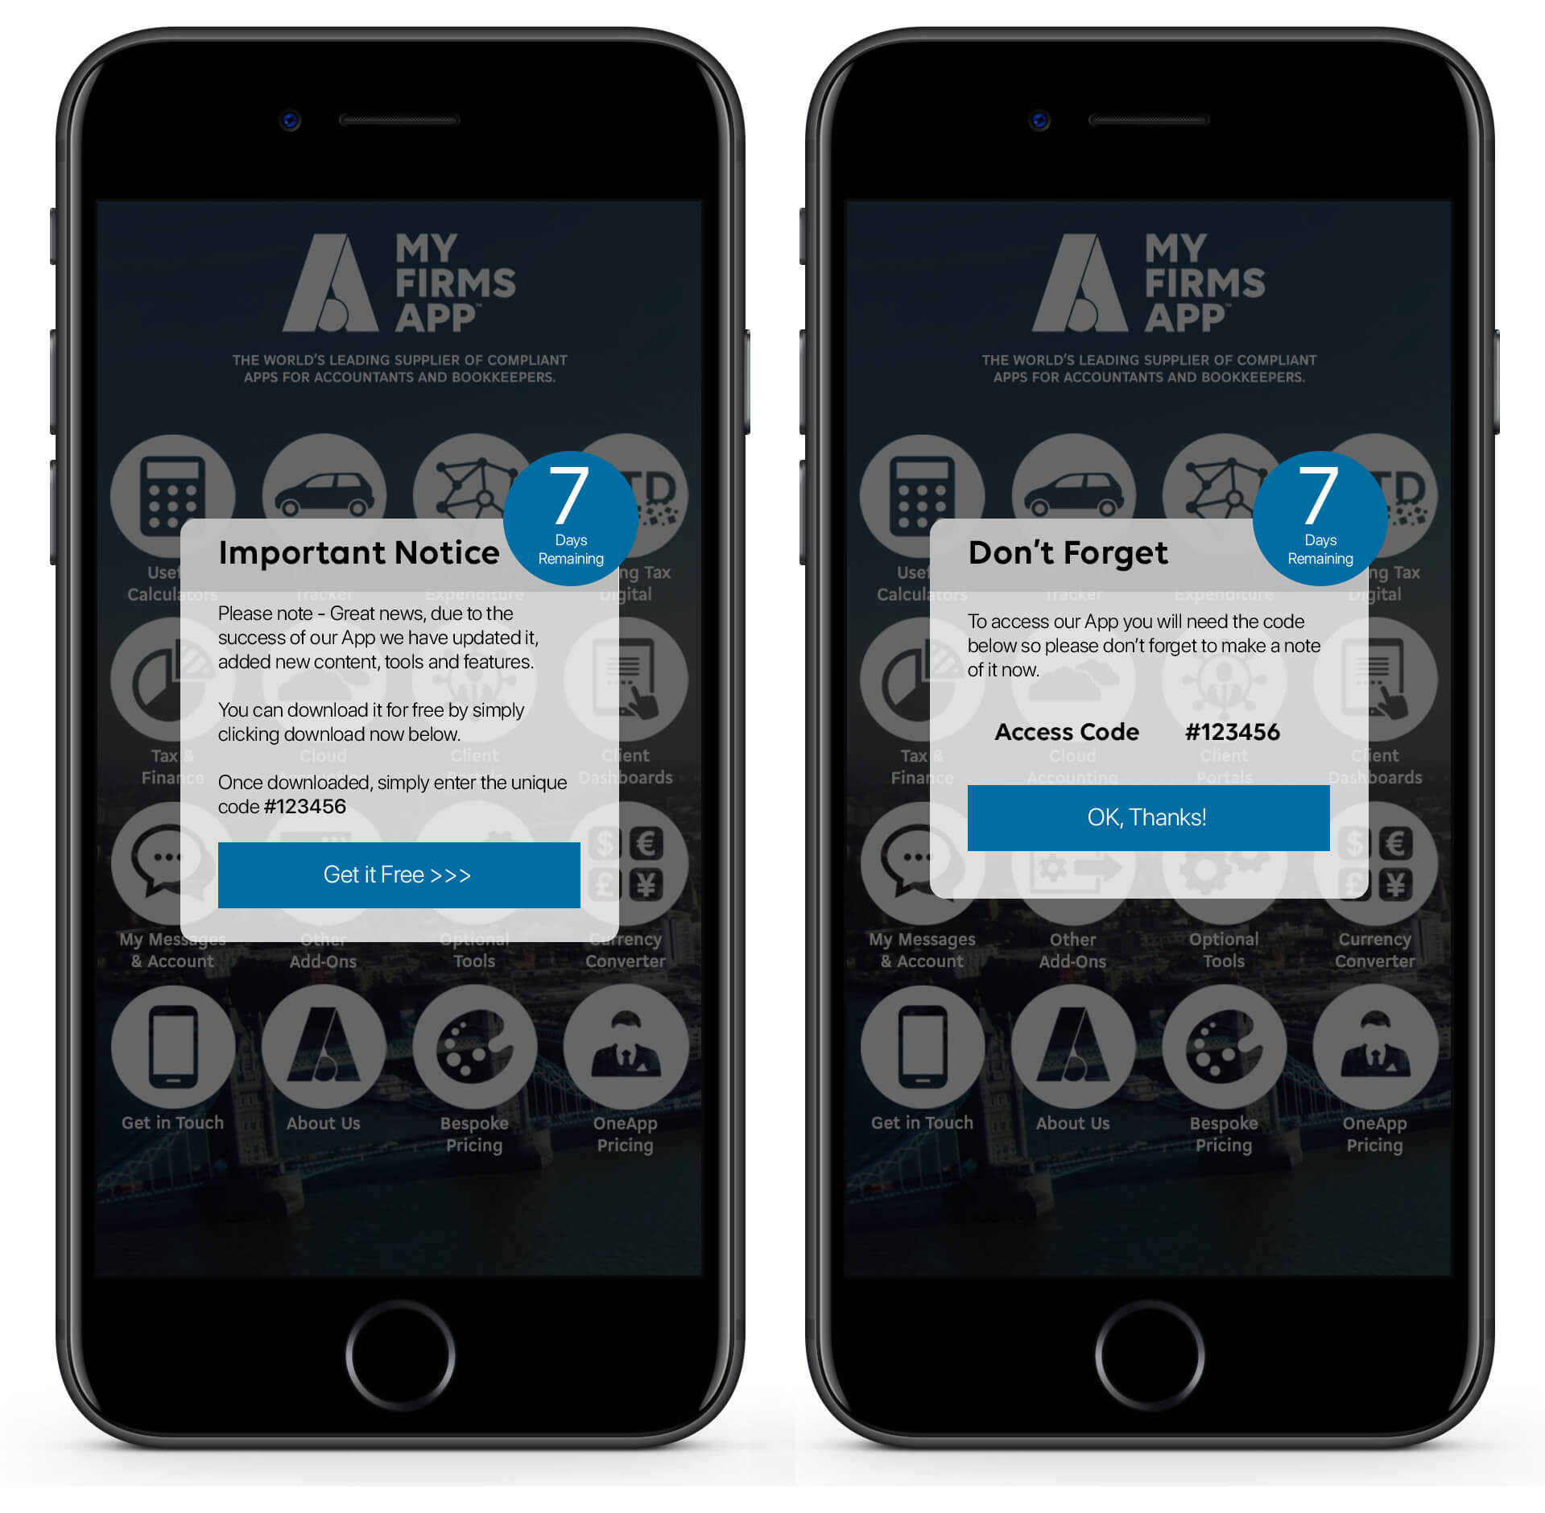

1) Existing App Transition

Your existing App will remain live in the stores for 3-months after your new App goes live. After this period, we will automatically remove your App and notify your primary contact via email.

2) Support

If you have any questions or require support with your new App or moving you users to your new App, simply drop us a line or give us a call and we will be happy to help. See the bottom of the document for contact details.

3) App User Data

If you would like a download of your App user data, simply access this from your datastore. For assistance on how to do this, please contact us on the email or telephone numbers at the bottom of this document.

4) Automated Push Notifications

In order for us to help you get your existing App users to download your new App, we have pre-written the push messages shown below which will be sent out automatically via your existing App. You do not have to do anything, we will do all this for you. These messages will be sent out only once your new App is live.

Push 1 – week 1 App Live

Title: Drum Roll…
Teaser: We are excited to announce the launch of a brand new and improved App!

Text: As a firm, we are consistently looking for ways we can improve the service we offer our customers, and we are pleased to announce a major overhaul of our FIRM App. It is packed with lots of exciting new features to make your life, and the way in which we work with you, even easier.

Our existing App will cease to be supported so please do follow the link to download our new App and take advantage of its powerful new features.

You can get your free App here LINK

Push 2 – week 4 App Live

Title: Don’t forget
Teaser: To download our new App

Text: If you have not already downloaded our new and improved App, head over to the App store now to download it today.

It is packed with lots of exciting ne features which we know you are going to love.

Our existing App will cease to be supported so please do follow the link to download our new App and take advantage of its powerful new features.

You can get your free App here LINK

Push 3 – week 7 App Live

Title: You’ll love our New App
Teaser: What does the new App do?

Text:

The App will give you access to key accounting data, in real time, whenever you need it.

It App will enable you to calculate the tax on certain company cars or check the amount of tax you might be paying. It will give you the power to check Stamp Duty costs or see how you might increase your profits as a business.

You can also browse the library of tax tables, giving you the very latest tax rates 24/7 whenever you need them. From National Insurance and Inheritance tax to Income Tax and Tax Credits – it’s there for you.

Save hours with these 4 powerful tools:

- Never lose a receipt again with the powerful Receipt Manager!
- Track your daily, weekly and monthly income using the inbuilt Income Tracker.
- Manage your mileage on the go with the GPS Mileage Tracker!
- We can keep you updated on key updates via rapid Push Notifications, direct to your phone.

You can get your free App here! URL

Push 4 – week 12 App Live

Title: Last Chance
Teaser: This App is about to become obsolete

Text: We have replaced our existing with a brand new, all singing, all dancing App so this one will no longer be supported from next week.

The great news is that you can now download our powerful new App right now free of charge.

It’s packed with tools and information designed to make your life easier.

You can get your free App here! URL

5) Your App | Email Marketing | 2 Emails for Current Customers

Your Migration Emails

These are designed to be a plain text email sent out to your customers.

In order to help your migration of your existing App users to your new App, we have carefully crafted some pre-written emails for you to send to you App users. We have also written an email for you to send to other clients, prospects and users whom have not yet engaged with your App to help you get even more downloads and engagement with your App.

If you want to send a plain text email shot but are not able to do so internally, simply call 0800 803 0826 or email paulinem@myfirmsapp.co.uk.

Our experienced marketing team is always on hand to help with any area of App promotion, sales or marketing.

To use this page in Word simply use the find and replace feature.

If you don’t know how to use that feature, here is a link that explains it step-by-step http://bit.ly/2a42uee.

- Run Find and replace for FIRM and replace with your practice name
- Run Find and replace for URL and replace with your app landing page URL

Text email to send to App users

Subject line: Our New Updated FIRM App

Dear X,

As a firm, we are consistently looking for ways we can improve the service we offer our customers, and we are pleased to announce a major overhaul of our FIRM App. It is packed with lots of exciting new features to make your life, and the way in which we work with you, even easier.

Our existing App will cease to be supported so please do follow the link to download our new App and take advantage of its powerful new features.

You can get your free App here URL

What does the App do?

The App will give you access to key accounting data, in real time, whenever you need it.

It App will enable you to calculate the tax on certain company cars or check the amount of tax you might be paying. It will give you the power to check Stamp Duty costs or see how you might increase your profits as a business.

You can also browse the library of tax tables, giving you the very latest tax rates 24/7 whenever you need them. From National Insurance and Inheritance tax to Income Tax and Tax Credits – it’s there for you.

Save hours with these 4 powerful tools:

- Never lose a receipt again with the powerful Receipt Manager!
- Track your daily, weekly and monthly income using the inbuilt Income Tracker.
- Manage your mileage on the go with the GPS Mileage Tracker!
- We can keep you updated on key updates via rapid Push Notifications, direct to your phone.

You can get your free App here! URL

Finally, if there is anything more FIRM could be doing for you or if there’s anything you think we should improve, please get in touch. We are happy to receive feedback about our services, both negative and positive.

Yours faithfully,
Name | Title | Email

P.S. Do feel free to share the App with any of your colleagues or connections who you think might find the App useful.

Text to send to customers and prospects who have not already downloaded the App

Subject line: Your Free App from FIRM

It’s just landed! The Brand new App from FIRM

Dear X,

As a firm we are constantly looking for ways we can improve the service we offer our customers, and we are proud to announce the launch of our brand new FIRM App. It’s completely free of charge and it’s available for iPhones, iPads and Android devices.

So the next time you need to look up a tax rate or work out a VAT calculation, our new App can help. It provides you with up to date, important accountancy data at your fingertips.

Save hours with these 4 powerful tools:

- Never lose a receipt again with the powerful Receipt Manager!
- Track your daily, weekly and monthly income using the inbuilt Income Tracker.
- Manage your mileage on the go with the GPS Mileage Tracker!
- We can keep you updated on key updates via rapid Push Notifications, direct to your phone.

It’s available for iPhone, iPad and Android devices and it’s available free of charge today.

You can get your free App here! URL

Enjoy!

6) Smartphone Detection for Your Website

Please find below your links to help you add the smartphone detection code to your website.

SMARTPHONE DETECTION

For technical help and assistance please call us or email support@myfirmsapp.co.uk UK 01325 469603 | AU 0280 155480 | USA 347 7489098

7) Smart QR code

Our team will set up and generate a unique, intelligent QR code for you to use on all your promotional activity. This awesome little tool will automatically detect which version of Smartphone your prospect is using and direct them to the relevant App store (Apple or Android). This will be sent to you by email when your App is live. If you do not receive it, please email us at Customer.success@myfirmsapp.com

CONTACT US

Customer.success@myfirmsapp.com
GLOBAL +44 (0) 1325 469 603
UK 0800 803 0826
AUSTRALIA 02 8015 5480
USA 347 748 9098

