Blog Articles - PLUS bonus content with our thanks

As part of our philosophy, we always try where possible to under promise and over-deliver. So in addition to the 2 potential client emails you have paid for, at the end of this document you will find an additional 5 free blog articles you can use if you wish to further enhance your email marketing and get even more from your App.

Remember that our team is always available to help with any aspect of sales, marketing or practice growth. They can help with blogging:

- Providing bespoke blog copy
- Provide images and designs for your blog
- Help you build an integrated blog that automatically updates all social media
- Help sharing blog material
- SEO of blogs and how to ensure they rank

This is designed to be a blog template you can tweak/amend to send out through your blog. If you do not yet have a blog, this is something we can help you with; Simply contact support@myfirmsapp.com.

Using this document:

To use this page in Word, simply use the find and replace feature. If you don’t know how to use that feature, here is a link that explains it step-by-step http://bit.ly/2a42uee.

- Run Find and replace for FIRM and replace with your practice name
- Run Find and replace for COUNTY and replace with your county
- You will need to add your own links to Apple Store, Google play and your QR codes

Design note – This template is for content only and needs to be sent through your blog in the style and format you are used to, preferably with screenshots or images of your App. If you don’t have access to a design team or are new to blogging, simply contact support@myfirmsapp.com.

SEO note: If you are already blogging then you should already be familiar with the Search Engine Optimisation (SEO) and what to add. The SEO benefits of blog articles are huge. If you are not experienced in adding the SEO below, we have created a template for your 2 App blog articles. If you need further help or assistance, please get in touch.

Blog 1 SEO

Title:
Accountants in COUNTY Launch Powerful App | FIRM Accountants in COUNTY
Meta Description:
FIRM Accountants in COUNTY release this brand new App that’s free for clients and our friends looking to achieve more on the move.
Meta Keywords:
New App for COUNTY companies

Blog 1 Copy

It’s landed!

The Brand new App from FIRM

As a firm we are constantly looking for ways we can improve the service we offer our customers and we are proud to announce the launch of our brand new FIRM App. It’s completely free of charge and it’s available for iPhones, iPads and Android devices.

So the next time you need to look up a tax rate or work out a VAT calculation, our new App can help. It provides you with up to date, important accountancy data at your fingertips. PLUS:

Photo Receipt Management, Email and Store
Never lose a receipt again! Using the latest App, you can track receipts and expenses literally at the touch of a button. With minimal effort you can take a picture of any receipt and save it to your App. Any additional information can be added later and receipts stored by amount, category, and date. It can help you track all your expenses with ease and enable us to interact digitally with you.

GPS Mileage Tracking and Management tool
When it comes to mileage tracking, half the battle is keeping an accurate tab on your journeys. Using the built-in GPS on your device, it will automatically track your mileage, helping you to record every single trip at the touch of a button. It also manages trips as well, storing them and allowing you to view, edit or email them with complete ease.

Keeping in touch via ‘Push Notifications’
As a firm we are committed to finding ways to communicate and interact with clients in the most efficient possible way. The new App enables us to send push notifications to all App users. We will be using this feature to share important news, deadline reminders and financial updates with you.
This App was designed to provide every service you could ask from us. We’ve put your favourite business systems, invaluable tools and features such as calculators, tax tables, logbooks, receipt and income management, instant access to the latest financial news and information and valuable company info, directly from us. With all this on one App, our App will likely be your go-to tool in the future.
It’s available for iPhone, iPad and Android devices completely free of charge right now!

Enjoy our App with our compliments!

Blog Article Two | to send 4 weeks after the App is live

SEO

Title:

Why FIRM Clients Love this Free App | New App from FIRM

Meta Description:

Clients of FIRM Accountants in COUNTY love this new App that enables them to access key calculators, tax sheets and accounting dates 24/7
Meta Keywords:

New App for COUNTY companies

Copy:
Why FIRM clients love the new App

The Brand new App from FIRM

It’s now 4 weeks since FIRM launched the new iPhone and Android App. Since then, clients and contacts have downloaded it across COUNTY.

The App has generated some fantastic feedback from users enjoying its many features for free.

It’s also helped FIRM get recognition for being a proactive firm of accountants that is prepared to reach out to its clients in an innovative manner.

The 5 things that clients enjoy the most from the App are:

- Photo receipt and management tool – never lose a receipt again!
- GPS Mileage tracker
- 15 + Free calculators from income tax to inflation: it’s all there
- Helpful, handy Tax sheets
- Key Tax Dates

So if you haven’t got your copy of the App yet, it’s available right now for iPhone, iPad and Android devices. Simply click on the relevant link below or scan the QR code.

Enjoy!

Bonus Blog Article 1 | General blog on closing Apps in iOS and above

SEO Title:
YOUR NAME How to Close Apps on iOS | Closing App iPad | Force App Closure iOS

Meta Description:
Great blog on how to close Apps on iOS from proactive accountants, YOUR NAME
Meta Keywords:
How to close Apps on iOS
Alt Tags
How to close Apps on iOS
Closing Apps on Apple Devices
Why close Apps down? Force closing Apps
COPY:

How to close Apps in iOS on the iPhone, iPad or other iOS devices
As more and more of our clients are using iPhones, iPads and other iOS devices, we want to blog about closing Apps in iOS.
Your smartphone or iPad is a hardworking tool, capable of literally almost anything, including of course running our latest free App – you can get that here (INSERT LINK).
Telephone calls happen to be a small part of what most of us use our Apple devices for these days. More frequent use includes emails, Apps, directions, purchasing equipment and thousands of other tasks. After carrying out hundreds of App demonstrations with financial services firms, it has become clear that many users were unaware that their phone was running Apps in the background.

Why bother closing Apps?
What many people do not realise is that by allowing these Apps (sometimes twenty or more) to run in the background, they are wasting a huge amount of the device’s processing speed and battery life. No wonder they have to keep recharging.
Some users we spoke to had never closed a single App – ever! That meant they were running a high number of Apps, slowing their device down and reducing its battery life and length.

How to close an App in iOS and later OSes:
To close down those sneaky background Apps in the new operating system is much easier than in previous versions. The first step is to access the task bar on the device.
Simply press the ‘Home Button’ twice, quickly:
If you are used to previous versions of IOS, then the first thing you might notice is that the home button no longer shows you a drawer with the icons of open Apps. Instead you will see ‘cards’ that contain a screenshot of each of your open Apps. Beneath these card images you will see the App icon. In the example to the left you can see 3 open Apps.
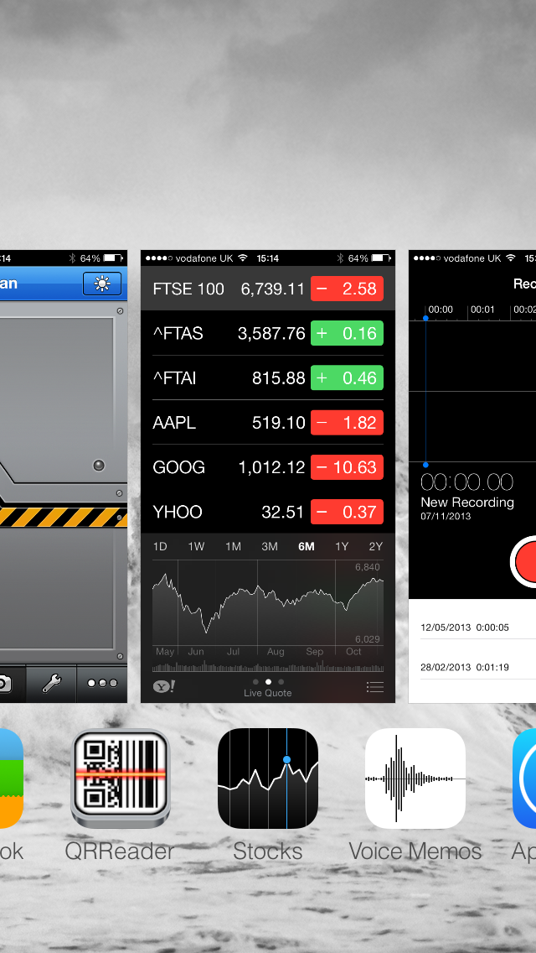
You can swipe in either direction between the Apps. Swiping all the way to the left will take you to the image of your home screen, whilst going to the right reveals more open Apps (if you have more open).
Tapping on the App image will then launch or return you to that App.
To close the App (or force an App to close that’s unresponsive) is actually very simple, although it isn’t immediately obvious.
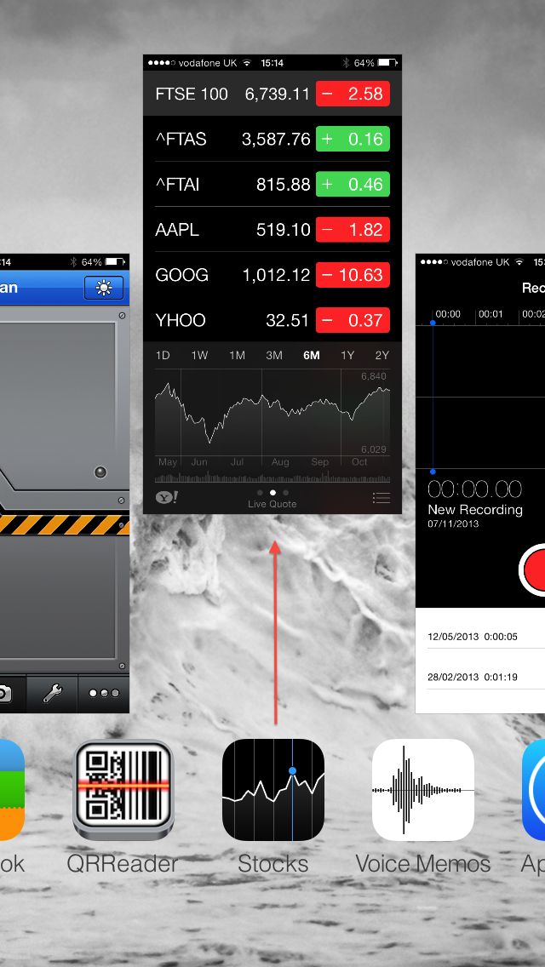
All you need to do is place your finger on the image of the App you wish to close and drag your finger upwards (forwards). This will drag the App upwards on your screen and it will fly off and close.
This simple process will dramatically speed up the iPhone, iPad or device and extend the time it will run on a single charge.

Bonus Blog Article 2 | Clients Receipt Management

SEO Title
Receipt Management | Free Receipt App | YOUR NAME

Description

Never lose a receipt again; use the free receipt management App from proactive YOUR LOCATION Accountants – YOUR NAME

Keywords

Receipt App, Proactive YOUR LOCATION Accountant

Alt Tags for images

Proactive YOUR LOCATION Accountant
Receipt App YOUR NAME

COPY

H1 | Simple, easy and efficient receipt management

Managing your receipts can be a tough task. Trying to keep track of all those important business expenses and receipts can be a nightmare: pockets overflow, wallets become crammed with them and inevitably, many are lost. If you are claiming back expenses and/or the VAT then this can be of significant cost and frustration.

Over the years, as a firm of proactive accountants in YOUR LOCATION, we have seen it all. From envelopes and shoeboxes overflowing with receipts to carrier bags and plastic wallets.

H2 | There is a much easier way and it’s free!

As a modern, forward thinking firm we are always looking for new and improved ways of doing things. So when we launched our Apple and Android-Approved App, one of the important features was Receipt Management - A super easy way that all businesses (both clients and non-clients) could store and manage their receipts. And here it is, the YOUR NAME Receipt Manager.

It’s built into the App, which is available free from either, the Apple or Android store. Simply search for YOUR NAME Tax in the relevant store and download the App free.

H3 | How does the YOUR NAME Receipt Manager work?

First, you need to download the relevant App (see above). Once you have the App, simply click on the home page icon labeled ‘Receipt Manager’. This will open a window just like the one opposite.

Before you get started, enter your name and company name into the ‘My settings’ section of the receipt tool.

H4 | Photograph a Receipt

You can take a photo using the 'Photograph a Receipt' button. Selecting this will automatically open the 'Categories' tab where it will prompt you to select the category you wish to save your receipt under something like Travel Expenses, Property Costs, Personal Receipts and so on.

Once you have selected the category for your receipt, you can then photograph it automatically, using the in-built camera in your Smartphone or tablet. Once you have focused and taken the picture of your receipt, it will give you the option to 'use or retake'. Once 'use' is selected, you must now fill in relevant data regarding the receipt.

We have made these fields compulsory, as this data is enormously helpful if you are keeping track of numerous receipts. It also gives you the chance to add a specific note - a very useful feature if you have a receipt that your accountant or HMRC might later question.

Once the data is entered, simply click 'save' and your receipt is saved. They can later be found within the category you selected to save it under.

Exporting & Managing Receipts

To view, export and manage your receipts simply click 'Manage Receipts' then click on a specific category i.e. Travel Expenses. All receipts in that section will be shown.

Exporting your receipts is simple, fast and easy. To export a single receipt, simply click on the receipt to manage, then scroll down and you have 3 options - Email, Export or Delete.

Exporting all receipts

To export all your receipt data, simply click 'Manage Receipts', then scroll down to the bottom, and select 'Export All'. This will allow you to select the date range of the receipts you wish to export.

The image of your receipt(s) is stored locally on your device, in your 'photo' section. To send these images, simply send by email when on a good Wi-Fi connection, use 'photo-stream' if it’s an iOS product, or one of the free and hugely popular cloud storage tools such as DropBox.

Bonus Blog Article 3 | General blog on smartphone use

SEO Title:
YOUR FIRM Accountants App | Mobile and Smartphone Growth | YOUR LOCATION Accountancy Firm

Meta Description:
Why business owners need to face up to the challenge of Mobile and Smartphone growth
Meta Keywords:
Smartphone growth, smartphone and Apps, YOUR FIRM App

Alt Tags
Smartphone growth, smartphone and Apps, YOUR FIRM App

Copy:
Why business owners need to face up to the challenge of Mobile and Smartphone growth

The business landscape is not simply evolving; it’s changing dramatically, thanks to mobile technology.

Back in 1992 a 22-year-old test engineer sent the world’s first text message. Today, more than 8 trillion texts are sent each year and in October 2015 global users of Smartphones reached an astonishing 1.5 billion.

The Smartphone that sits comfortably in the palm of your hand has more computing power than it took to put the first man on the moon! You know how helpless you feel when you can’t access your emails? That shows how dependent the business community has become on technology. It’s an integral and essential part of everyday business life.

And what’s the next ‘big thing’ that business owners and entrepreneurs need to face up to? It’s the challenge of Mobile and Smartphone technology.

It affects you - Now!

Some readers may think that responding to these changes in technology is somehow optional. In the sense that if you don’t respond, things will carry on as before.

But ‘normal’ doesn’t exist any more! The days of people visiting your website via a PC, for example, is disappearing fast. As you read this, mobile technologies are already having an impact on your business.

I mentioned earlier that global users of Smartphones are now in excess of 1.5 billion. A recent survey undertaken by Accounting Web and MyFirmsApp showed that over 85% of UK businesses relied on Smartphones for internal and external communication and as their primary route to the Internet. Over 50% of local Internet searches are carried out by a mobile device.

Let’s put all that into context.

Over half of the people visiting your website no longer view it through a PC or laptop. Instead, they are viewing your website through a Smartphone or tablet.

Have you visited your own website via a mobile to see what your clients and prospects see? Is it fast to load, simple to navigate and easy to contact you using it? If it isn’t, you are likely to be losing customers and potential customers before they even contact you.

Your customers

A survey by Accounting Web showed that 85% of businesses used smartphones and Apps. That means it’s highly likely that your customers and potential customers are trying to communicate with you and your website using these devices. What your clients used to do by telephone, PC or face-to-face, they now do via an App. And if your business isn’t geared to this technology, they’ll transfer their business somewhere else – fast!

Agility is important

One of the hallmarks of a successful business is its agility. Flexible, open-minded directors and managers who are ready to embrace technological, commercial and economic changes and turn them to their advantage. In an uncertain world, if you can offer a response to the technological changes then your customers and potential customers will welcome it. Historically, agility may have meant adapting and responding over a period of months. It’s not like that anymore! Having technology at your fingertips 24-7 in real time, anywhere, means you have the ability to respond ultra-fast.

If you would like to discuss how you can prepare your business for the challenge of mobile and smartphone technology, please contact us here.

Bonus Blog Article 4 | Clients tracking business miles

SEO

Title:
YOUR FIRM Accountants App | Tracking Business Miles | COUNTY Accountancy Firm

Meta Description:
The easy way to track business mileage using the YOUR FIRM App
Meta Keywords:
Business mileage calculator, business GPS tracking

Alt Tags:
Tracking business miles with the FIRM App
Accountants App helps businesses in COUNTY track business miles

COPY

How to keep track of your business mileage with the YOUR FIRM App

Do you claim for business mileage – and spend hours Googling the places you’ve visited to work out the miles you’ve covered?

Well, thanks to the YOUR FIRM App, you can now get all the information you need permanently recorded on your Smartphone. Just set the Mileage Calculator to ‘Start Trip’ and thanks to the wonders of GPS tracking, your precise journey and the exact mileage covered will be recorded for you. When you get to your destination, click ‘End Trip’ and all the details will be saved.

You can view a list of all the trips you have made, including dates, times and miles covered and you can even email the details to your accountant, head office, payroll section – whoever needs the information.

It’s a really useful feature of your YOUR FIRM App. If you haven’t used it yet, give it a try. We think you’ll be impressed.

If you would like to arrange a meeting to discuss any specific issue related to company cars or the tax implications of reclaiming mileage, please CONTACT us here.

Bonus Blog Article 5 | General Blog Article on App use

SEO Title:
Will Apps replace Websites? | Are Apps going to kill the Web? | FIRM

Meta Description:
Will Apps replace websites? Check out the latest blog post from FIRM
Keywords:
Will Apps replace websites? Check out the latest blog post from FIRM

Alt Tags:
Will Apps replace websites? Check out the latest blog post from FIRM

COPY:

H1: Will Apps replace websites? Are we witnessing the death of the web?

It’s a subject that’s been causing debate in technology circles for quite a while now. In fact, as long ago as 2011 Forrester CEO George Colony gave a speech where he proclaimed the death of the web and the emergence of the “App Internet.”

To bring home the logic of Colony’s claim, let’s look at your own habits and see whether the foundation for this change is Apparent from your behavior. Do you own an iPad or tablet? Have you ever downloaded an App? Perhaps the eBay App? Facebook, LinkedIn or Twitter? Then chances are that you already have a number of Apps on your iPhone or tablet. They are easy to use, aren’t they? And you don’t have to fiddle around with a browser and search for the website. One click on the App and you’re in.

But times change; technologies change. And it’s our responsibility as trusted accountants to move with the times. That’s why our website is mobile-enabled; it’s easy to navigate around our site even if you are viewing it on a Smartphone. And that’s also why we have invested in an App. We believe in the not too distant future most businesses – yes, even the most crusty old accountancy firms! – will have Apps as the technology of choice to interact with clients and prospects and to distribute information. Calculators are available at the touch of a button; receipt management, mileage management, blogs, FTSE prices, are all available instantly to everyone using your App.

H2: What can a website do that an App can’t?
The simple answer to this question is ‘Nothing’. The App can run calculators that aren’t available on any website; it can track your mileage and income as well as log receipts; it can send push messages to all your users and much more. The App can also provide the user with important data from the website; details about your firm, your team, directions, contact details, mail forms etc. all available in the palm of their hand 24/7.

H3: Other companies are leading the way
As is so often the case, other industry sectors are leading the way. All the banks have Apps; BBC News, Sport and Weather have their own individual Apps. Indeed, there’s an App for just about anything.

So perhaps it’s not so far-fetched to consider a future in which the App will be the only point of entry to the Internet. Colony was right. Tomorrow is here.

Bonus Blog Article 6 | General Blog Article on App use

SEO

Title:
YOUR FIRM Accountants App | Converting Currency | COUNTY Accountancy Firm

Meta Description:
The easy way to convert currency using the YOUR FIRM App
Meta Keywords:
Currency converter, conversion

Alt Tags:
Converting currency with the FIRM App
Accountants App helps businesses in COUNTY convert currency

COPY

How to convert currency the easy way with the YOUR FIRM App

We’ve all been there. Whether it is a business trip or a well-deserved vacation, we have all been in the situation where we are trying to figure out just how much the tax fare is really costing us, in our own currency. Or perhaps you are making an internet purchase from an overseas vendor and want to make sure you are really getting the bargain you think you are?

Well, thanks to the YOUR FIRM App, you can now make those currency conversions quickly and easily wherever or whenever you need to.

We built into our App a super useful currency converter which covers all major currency and is updated live with up to the minute conversion rates. Simply tap on the Currency Convertor icon within our App and the world’s currencies are at your fingertips.

It’s a really useful feature of your YOUR FIRM App. If you haven’t used it yet, give it a try. We think you’ll be impressed.

If you need any support or advice on any currency matters please CONTACT us here.

Bonus Blog Article 7 | General Blog Article on App use

SEO

Title:
YOUR FIRM Accountants App | Useful Calculators | COUNTY Accountancy Firm

Meta Description:
Super useful financial calculators using the YOUR FIRM App
Meta Keywords: Financial calculators, Capital Gains Tax . Dividend versus Salary . Corporation Tax . Income Tax . Increased Profit . IHT . Contractor . Should I Incorporate? . APR . Stamp Duty . Inflation . VAT . Payslip . Loan . Company Car . Mortgage . Savings

Alt Tags:
Financial calculators with the FIRM App
Accountants App helps businesses in COUNTY with key financial calculators

COPY

Save time on decisions thanks to key financial calculators with the YOUR FIRM App

Making good decisions quickly often relies on access to key facts, figures and information. But swift access to reliable information is often a stumbling block which wastes time and effort.

Thanks to the YOUR FIRM App, you can have key financial information at your fingertips thanks to a suite of super useful calculators that will save you hours of time. They are all here, in the App and always up to date.

UK APPS

Capital Gains Tax . Dividend versus Salary . Corporation Tax . Income Tax . Increased Profit . IHT . Contractor . Should I Incorporate? . APR . Stamp Duty . Inflation . VAT . Payslip . Loan . Company Car . Mortgage . Savings

USA APPS

APR . Increased Profit . Loan . Mortgage .Savings

AUS APPS

Income Tax Individuals. Company Tax. PAYG Withholding . Super Contribution Caps Calculator . Capital Gains Tax . Goods and Services Taxes (GST) . Fringe Benefits Tax . Loan Repayment . Gross Pay. Super Salary Sacrifice (Cost/Benefit). Domestic Meal Allowance. Stamp (Transfer) Duty

Simply tap on the CALCULATORS icon within our App and browse the selection of calculators we have prepared for you.

It’s a really useful feature of your YOUR FIRM App. If you haven’t used it yet, give it a try. We think you’ll be impressed.

If you need any support or advice on financial matters please CONTACT us here.

